De Anza College
Student Equity Plan and Executive Summary
2019 - 2022
Executive Summary
De Anza College’s Equity Framework
Over the past two Educational Master Plan documents, spanning over a decade, De Anza has remained committed to reducing its achievement gap to no more than a 5% difference between targeted (African American, Latinx, Filipinx) and non-targeted students groups. This commitment is institutionalized as part of the college’s annual program review process in which each program needs to analyze, evaluate and report on their equity gaps and their activities aimed at lessening those gaps. It is our commitment to ensure that equity principles are not only embedded throughout our decision-making processes via program review, but also part of our organizational-sociocultural development, pedagogy, and leadership strategies. Our 2017 accreditation Quality Focus Essay further included a college-wide commitment, vision and plan towards closing our equity gap. This equity plan serves as an additional re-enforcement of the work the college undergoes on a daily basis to ensure equitable access and outcomes for all student groups. Equity has been, is, and will remain the lifeblood of De Anza College. Equity is what drives many staff and faculty to join the De Anza community and is one of the main reasons students travel great distances to be part of the De Anza community. The community that together, we create.

Our commitment to equity has always stemmed from our mission which incorporates language which uniquely defines De Anza. The mission statement was updated in spring 2014 as part of the writing of the Educational Master Plan, 2015-2020. The mission statement clearly articulates student learning goals and outcomes, the importance of civic engagement to democracy an emphasis on success for every student in multiple areas of intellectual, personal and social development and competence. The De Anza community is committed to its mission:

De Anza College provides an academically rich, multicultural learning environment that challenges students of every background to develop their intellect, character and abilities; to realize their goals; and to be socially responsible leaders in their communities, the nation and the world. The college engages students in creative work that demonstrates the knowledge, skills
and attitudes contained within the college’s Institutional Core Competencies:
• Communication and expression
• Information literacy
• Physical/mental wellness and personal responsibility
• Civic capacity for global, cultural, social and environmental justice
• Critical thinking
While it is clear that the De Anza community has always embraced a commitment to student equity, it has never been an overarching vision for the college, as we have not had a formal vision statement. In 2018-19 the college took the opportunity to create a vision statement which further re-affirms our commitment to equity. The vision statement also emphasizes the importance of helping students develop an equity-based mindset which they can take with them to future communities they may join or create in their lives. The De Anza community is committed to its vision:
Empower all students to attain their educational goals, develop an equity-based mindset and become civic leaders in their communities.
In addition to embracing equity in our mission and vision statements, we also value equity, among other essential values, in which the De Anza community is committed:

Integrity
We embrace honesty, credibility, clear communication and acting on our stated values. We strive to acknowledge and address issues that may be difficult to broach. The college’s ability to fulfill its mission depends on a college community in which everyone feels included, respected and safe.

Innovation
In all of our many roles, we will continuously and purposefully reflect in order to innovate and improve. We work to ensure our physical space is welcoming, conducive to learning and environmentally sustainable. We are committed to being innovative in our daily work, curriculum and use of technology. We work with our students to be creative, flexible, imaginative and inventive, and to prepare to contribute to a world that will demand skills and competencies not yet in view.

Equity
We welcome students of all ages and backgrounds and connect with them, in their range of unique circumstances, to help them fulfill their dreams. We strive to design classes and services to the needs of those we serve. We value and embrace the intellectual contributions of a diverse spectrum of people and cultures. We strive for a diverse workforce that honors the contributions of all who work here.

Developing the Human Capacity of All Students
We will provide support in six key factors of student success. Our students will be:
- Directed, with a goal and the knowledge of how to achieve it.
- Focused, staying on track to achieve that goal.
- Nurtured, feeling that we want to, and do, help them to succeed.
- Engaged, actively participating in class and extracurricular activities.
- Connected, feeling that they are part of the college community.
- Valued, with their skills, talents and abilities recognized, and with opportunities to contribute on campus and feel that their contributions are appreciated.

Civic Engagement for Social Justice
We provide students with opportunities to enhance their potential for purposeful and productive lives. As a public institution, we contribute to the development of our local, state, national and global communities. We view our students and ourselves as agents of change, responsible for building the world in which all people are able to realize their dreams in ways that are environmentally sustainable and in alignment with the United Nations' Declaration of Human Rights.
[Insert values pin wheel here]

Student Equity Plan Goals and Activities – 2019 to 2022

Methodology: In order to calculate disproportionate impact (DI) for various student groups, the percentage point gap (PPG) method that was specified by the Chancellors Office was used. PPG compares the outcome rate of the group to the outcome rate of the overall group in which it is being compared to, the difference between the groups is the gap. The margin of error used to determine DI was provided by the Chancellors' Office and was calculated for each group based on a Z score for a 95% confidence interval. When student characteristics were further disaggregated by gender, achievement outcomes for each gender group were compared with the outcomes of the corresponding gender population. This method intended to increase the precision of the PPG measurement and to decrease the standard error between disaggregated gender groups and the student population. De Anza used this methodology to compare within gender rather than to the whole population, making the comparison more precise.
Access-Enrollment: The baseline data for the overall student population in 2017-18 is 52% of students who apply and then enroll at the college. The college has set a goal of 52% for this goal based on historical trends over the past 4 years. Disproportionate impacts for various student groups were identified:
  - Foster Youth, Female: increase from 45% to 50% or an additional 22 students
  - Veteran, Female: increase from 36% to 50% or an additional 20 students
  - American Indian/Alaskan Native, Female: increase from 42% to 50% or +16 students
  - African American, Female: increase from 43% to 50% or an additional 114 students
  - Unknown/Not Reported, Female: increase from 44% to 50% or an additional 21 students

Retention: The baseline data for retention from fall to winter is 74% in 2017-18 and the college has set a goal of 75% based on historical trends over the past 4 years. Disproportionate impacts for various student groups were identified:
  - Foster Youth, Female: increase from 62% to 72% or an additional 14 students
  - Foster Youth, Male: increase from 58% to 75% or an additional 19 students
  - LGBTQQI, Female: increase from 62% to 72% or an additional 53 students
  - LGBTQQI, Male: increase from 68% to 75% or an additional 19 students
  - Veteran, Male: increase from 66% to 75% or an additional 29 students
  - African American, Female: increase from 65% to 72% or an additional 24 students
  - African American, Male: increase from 65% to 75% or an additional 33 students
  - Latinx, Female: increase from 69% to 72% or an additional 86 students
  - Latinx, Male: increase from 71% to 75% or an additional 109 students
Transfer to a Four-Year University: The college is currently at 3,026 total students who transferred to a four-year university in 2017-18 and would like to increase that to 3,289 based on historical trends over the past 4 years. Disproportionate impacts for various student groups were identified:

  - Disabled, Male: increase from 7% to 9% or an additional 24 students
  - LGBTQQI, Female: increase from 7% to 10% or an additional 19 students
  - LGBTQQI, Male: increase from 7% to 9% or an additional 12 students
  - Latinx, Male: increase from 6% to 9% or an additional 132 students
  - African American, Male: increase from 7% to 9% or an additional 11 students

Completion of Transfer Level English and Math: The college currently has a completion rate of both transfer level math and English in one year of 17% and would like to increase that to 18% in three years. Disproportionate impacts for various student groups were identified:

  - Disabled, Female: increase from 7% to 16% or an additional 4 students
  - Foster Youth, Male: increase from 3% to 17% or an additional 4 students
  - LGBTQQI, Female: increase from 7% to 16% or an additional 9 students
  - African American, Female: increase from 7% to 16% or an additional 5 students
  - African American, Male: increase from 10% to 17% or an additional 6 students
  - Latinx, Female: increase from 9% to 16% or an additional 35 students
  - Latinx, Male: increase from 8% to 17% or an additional 60 students
  - Pacific Islander, Male: increase from 5% to 17% or an additional 2 students

Achieved Vision Goal (Earned credit certificate over 18 units or associate degree): The college awarded 2,698 awards in 2017-18 and would like to increase that to 2,815 in three years. Disproportionate impacts for various student groups were identified:

  - LGBTQQI, Female: increase from 5% to 7% or an additional 21 students
  - Pacific Islander, Female: increase from 1% to 7% or an additional 4 students
  - Unknown/Unreported, Male: increase from 3% to 6% or 5 additional students

Actions to Achieve Our Goals

Guided Pathways: At De Anza, our faculty-led Guided Pathways work is heading towards this strategy of aligning and integrating our college's initiatives and programs in Students Services and Instruction to our Vision For Success goals through the leadership of a faculty Guided Pathways coordinator who will work with Guided Pathways administrator and staff coordinators to align the Guided Pathways and Vision For Success goals, and also form and facilitate Guided Pathways cross-functional design/work teams with faculty, student, staff, and administrator membership/participants. Each design/work team will focus on achieving specific components of our Vision For Success and Guided Pathways goals. The coordinators will facilitate the teams' work, and regularly check in on and update Institutional metrics, Vision For Success, and Guided Pathways work plan goals as the teams progress further into the work.

Outreach and Relations with Schools: We will continue our partnerships with local high schools which now includes assessment and educational planning at 42 high schools each spring for the following fall term. There are over 250 outreach events each year that range from workshops, tabling, and presentations. One such event is Open House, at this event prospective students and their families are made aware of available student services and supports from our foster youth support services, Disability Support Programs and Services (DSPS), Extended Opportunities Programs and Services (EOPS), Financial Aid, Veterans Resource Center program, computer labs, and tutoring centers. As well as academic learning communities including PUENTE, Umoja, Learning in Communities (LinC), Latinx Empowerment at De Anza (LEAD), the Honors program, Men of Color, Rise and Reach.

Office of Communications: The college Office of Communications has undertaken several initiatives that serve to assist and encourage students in completing the enrollment process, including; Redesigning the college website, with new webpages that guide all applicants through the steps for priority enrollment and provide streamlined access to information about academic programs, placement, financial aid, the De Anza College Promise and other services; Sending email and text messages every quarter to inform students about upcoming enrollment dates, including special messages to remind students who have applied but not yet enrolled; Creating an extensive video tour of the campus, used in outreach events at local high schools and available for viewing online; Developing explanatory videos that show easy steps to apply for admission, get priority enrollment, apply for financial aid and complete other important procedures; Collaborating with the Office of Outreach and Relations with Schools in creating postcards, flyers, emails to high school principals and counselors, and event programs for conferences with underrepresented high school students; Using social media to share information with current and prospective students; Developing radio, video, internet and transit advertising campaigns to reach prospective and historically underrepresented students.

Food Pantry and Community Services: A mobile food pantry is available twice a month and provides students with fresh produce, meat, dairy products, dry goods and canned items. Along with the food pantry is assistance to register for Cal-fresh food assistance. The Outreach Office also operates a food pantry that is open on a daily basis. There is also a mobile farmers market once a week that accepts CalFresh, WIC, SSDI and Medi-Cal assistance. In addition to food services, De Anza students are able to ride VTA transit for free with their student id card, paid for through student fees to help with transportation insecurity. De Anza continues to explore opportunities to help students address, food, housing and transportation insecurity issues.

Foster Youth Services: The Guardian Scholars Program (GSP) assists current or former foster youth with full financial aid packages, academic advising, employment services, counseling, tutoring, textbook vouchers, meal vouchers, gas cards, child care and transportation help.

LGBTQQI Resources: The college currently has a resource room and safe space for LGBTQQI students within the Equity Office, with a designated part-time faculty-coordinator and student interns who can provide support to LGBTQQI students. The resource center also collaborates with other student supports services on campus to help LGBTQQI students feel supported and safe.

First Year Support Cohort Program: The outreach office works with new, first year students identified as not already part of a learning community or special program. The Outreach Office identifies these students at the beginning of each term and designates them to an outreach counselor who carries a caseload of students. The counselor creates their Educational Plan based on their major and education goal declared on the application, emails them personally to introduce themselves and encourages them make an appointment to discuss their education plan or address other needs they may have. A student ambassador supports the counselors with follow up outreach to engage the student with the outreach office and its different services. This program serves new students each year and follows them throughout the year with follow up communication to offer services and continued support.

Veterans Services: The center will provide book vouchers, wrap-around support services, academic counseling/advising, personal counseling, educational planning, career services, mentoring, veteran resources fairs, workshops, and provide a space for veteran students to build a sense of community. The veterans counselor and veterans resource specialist will work collaboratively to staff the Resource Center. The Veterans Resource Center will also provide $200 book vouchers for 100 veteran students.

Learning Communities: Continue to support and expand learning communities for disproportionately impacted communities including: Latina/o Empowerment at De Anza (LEAD; deanza.edu/lead/), Learning in Communities (LinC; deanza.edu/linc/), Puente Project (deanza.edu/puente/), and Umoja Scholars Program (deanza.edu/umoja/), Reading, English, Academic Support, Counseling, and Humanities (REACH; deanza.edu/reach/), First Year Experience (FYE; deanza.edu/fye/), Impact AAPI (deanza.edu/impact-aapi/), Men of Color (deanza.edu/mc2/), Humanities Mellon Scholars (deanza.edu/mellonscholars/), Vasconcellos Institute for Democracy in Action (VIDA; deanza.edu/vida/) and Math Performance Success (MPS; deanza.edu/mps/).

Revise Assessment and Curricular Pathways: As part of compliance with AB 705 (Irwin) the college has revised its assessment and placement processes. Students are now provided with a personalized email and their placement level upon applying to the college. Students are placed directly into transfer level English or math courses (ESL students are directed to ESL courses) with varying levels of support based on their high school transcripts or via Guided Self-Placement. Within the first term of making the changes, disproportionate impacts in regards to access to transfer-level courses for Latinx students were removed. De Anza will continue to monitor success and throughput rates, make changes as necessary, and continue to support students to help them be successful. The college is hopeful that these changes will help improve completion rates and reduce disproportionate impacts for many of our targeted populations.
Activities to Support Each Goal – Overall Population and Disproportionately Impacted Groups

Metric | Baseline Data - 2017-18 | Goals for Overall Student Population
Access: Successful Enrollment: Overall Population | 52% | 52%
Access: Successful Enrollment: Disproportionately Impacted Groups | Foster Youth, Female: 45%  Veteran, Female: 36% American Indian, Female: 42% African American, Female: 43%  Unknown/Not Reported, Female: 44% | Foster Youth, Female: 50% or +22  Veteran, Female: 50% or +20 American Indian, Female: 50% or +16 African American, Female: 50% or +114  Unknown/Not Reported: 50% or +21
Activities to Achieve our Goals
We maintain strong collaboration with high schools and school districts in Santa Clara County and the surrounding region through our successful delivery of course services on-site in the high schools, our annual High School Partners Conference in the fall and our four High School Student Conferences in the winter and spring. High school outreach now includes assessment, placement and educational planning. Prospective students are also informed of learning communities and support services. The Office of Outreach now conducts on-site services at 42 high schools.
The application for spring, summer and fall open on February 1 of the previous academic year to ensure that students can begin their matriculation steps early and be prepared when beginning their educational careers with De Anza.
Online Orientation was developed and launched in fall 2015 to support online students and provide options for all students to meet priority enrollment requirements, and to ensure academic success. Online Orientation is available in Canvas through our single sign-on system.
The college no longer requires placement tests for placement into transfer-level math and English. Students automatically receive a course placement after they apply to the college. If their high school transcript information is available.
The Assessment website was enhanced to provide students with relevant information about the new placement process.
The Summer Bridge program is targeted at new students who may or may not have registered for the fall. It is a 4-day intensive orientation with assistance in applying for financial aid, and all other services available to them, it provides connections to role models and focuses on community building before classes even begin. It also encourages students to enroll in a cohort program.
The learning communities hold program orientations each summer (Puente, FYE, Umoja) to help orient students to the campus, provide counseling and peer mentoring services before the fall term starts.
The college website was recently redesigned, with new webpages that guide all applicants through the steps for priority enrollment and provide streamlined access to information about academic programs, placement, financial aid, the De Anza College Promise and other services.
The Office of Communications sends emails and text messages every quarter to inform students about upcoming enrollment dates, including special messages to remind students who have applied but not yet enrolled.
The Office of Communications created a video tour of the campus, used in outreach events at local high schools and available for viewing online.
The Office of Communications is developing explanatory videos that show easy steps to apply for admission, get priority enrollment, apply for financial aid and complete other important procedures.
The Office of Communications are collaborating with the Office of Outreach and Relations with Schools in creating postcards, flyers, emails to high school principals and counselors, and event programs for conferences with underrepresented high school students.
The Office of Communications is developing radio, video, internet and transit advertising campaigns to reach prospective and historically underrepresented students.
The Office of Communications recruits student models and selects photographs to represent all student communities, with particular attention to historically underrepresented students, in all printed materials, advertising and online publications.
Metric | Baseline Data - 2017-18 | Goals for Overall Student Population
Retention: Fall to Winter: Overall Population | 74% | 75%
Retention: Fall to Winter: Disproportionately Impacted Groups | Foster Youth, Female: 62%  Foster Youth, Male: 58% LGBTQQI, Female: 62% LGBTQQI, Male: 68%  Veteran, Male: 66%  African American, Female: 65% African American, Male: 65% Latinx, Female: 69% Latinx, Male: 71% | Foster Youth, Female: 72% or +14 Foster Youth, Male: 75% or +19 LGBTQQI, Female: 72% or +53 LGBTQQI, Male: 75% or +19 Veteran, Male: 75% or +29 African American, Female: 72% or +24 African American, Male: 75% or +33 Latinx, Female: 72% or +86 Latinx, Male: 75% or +109
Activities to Achieve our Goals
The Men of Color Initiative helps guide, connect and engage African American and Latinx male students with the De Anza community. The program has 2 designated counselors who developed strategies to better engage these populations, including creating a community and a mentorship program.
The Guardian Scholars Program (GSP) assists current or former foster youth with full financial aid packages, academic advising, employment services, counseling, tutoring, textbook vouchers, meal vouchers, gas cards, child care and transportation help.
There are now embedded counselors in each division (program or population specific) in addition to general counseling to provide targeted support to students wherever they are at.
The outreach office works with new, first year students identified as not already part of a learning community or special program. The Outreach Office identifies these students at the beginning of each term and designates them to an outreach counselor who carries a caseload of students. The counselor creates their Educational Plan based on their major and education goal declared on the application, emails them personally to introduce themselves and encourages them make an appointment to discuss their education plan or address other needs they may have. A student ambassador supports the counselors with follow up outreach to engage the student with the outreach office and its different services.
It is a hope that the reduction in basic skills math and English courses will result in more students completing English and math requirements and retaining more students overall.
The director of STEM pathways will continue to coordinate the Statway and Math Performance and Success Programs to ensure access and quality instruction for African American, Filipinx and Latina/o students. The director will develop campus partnerships with SSRS programs, Learning in Communities, Outreach and Relations with Schools, Business/Computer Science, and Biological and Health Sciences.
Continue to train faculty and staff on the use of the Inquiry Tool to enable faculty and staff to disaggregate data by various student groups and explore equity gaps.
Math Performance Success (MPS) has an embedded counselor and embedded tutors in each section.
VIDA builds a cohort of leaders through their Leadership and Social Change certificate program which results in a greater sense of community and organizing on campus.
A resource room and safe space for LGBTQQI students has been created and has a designated faculty coordinator and student interns who can provide support to LGBTQQI students. The center also collaborates with health services and psych services.
A food pantry, satellite food pantries, a mobile farmer's market, community resources such as help enrolling in Cal Fresh are available to students who face food insecurities.
The HEFAS program provides support, space and immigration services for undocumented students.
The learning communities (FYE, Puente, Umoja, and Impact AAPI) have embedded counseling, peer support, and integrated curriculum to help retain students.
CTE programs are exploring course sequences to ensure they are logical and can be completed in the shortest time frame possible. They are exploring course scheduling to fit best with the schedules of their student population and they are exploring ways to encourage CTE students to take a variety of general education courses in line with their educational goal.
The athletics program has a designated counselor and an academic advisor and some athletes participate in the Reading, English, Athletics, Counseling and Humanities (REACH) program.
Metric | Baseline Data - 2017-18 | Goals for Overall Student Population
Transfer to a Four-Year University: Overall Population | 3,026 | 3,289
Transfer to a Four-Year University: Disproportionately Impacted Groups | Disabled, Male: 7% LGBTQQI, Male: 7%  Latinx, Male: 6% African American, Male: 7% | Disabled, Male: 9% or +24 LGBTQQI, Male: 9% or +12  Latinx, Male: 9% or +132 African American, Male: 9% or +11
Activities to Achieve our Goals
The college now offers 14 Degrees for Transfer (ADT) which has resulted in an increased rate of students obtaining an ADT degree.
The International Student Programs Office (ISP) provides transfer support through a targeted college fair for international students. The Office also provides academic, career, personal, and immigration counseling and advising.
Cohort programs have a goal of helping students on their path to transfer, particularly for disproportionately impacted students.
The Transfer Center helps students research their options and make plans for a smooth transition to a four-year university or other institution. They provide advising in transfer planning, information about articulation agreements, workshops and information sessions, meetings at De Anza with representatives from UC and CSU and private and out-of-state universities.
The Honors program assists students through workshops and support in their coursework. The Honors program is looking to expand access to a higher rate of disproportionately impacted student groups.
Metric | Baseline Data - 2017-18 | Goals for Overall Student Population
Completion of transfer level math and English: Overall Population | 17% | 18%
Completion of transfer level math and English: Disproportionately Impacted Groups | Foster Youth, Male: 3% Disabled, Female: 7% LGBTQQI, Female: 7% African American, Female: 7% African American, Male: 10% Latinx, Female: 9% Latinx, Male: 8% Pacific Islander, Male: 5% | Foster Youth, Male: 17% or +4 Disabled, Female: 16% or +4 LGBTQQI, Female: 16% or +9 African American, Female: 16% or +5 African American, Male: 17% or +6 Latinx, Female: 16% or +35 Latinx, Male: 17% or +60 Pacific Islander, Male: 17% or +2
Activities to Achieve our Goals
Reduction in basic skills math and English courses and the integration of the Reading department into the English department.
Placement based on high school transcripts or Guided Self-Placement into transfer level math and English with varying levels of support.
The English and math departments have developed new curriculum to support students in transfer-level math and English courses including corequisite supports.
Math, English and ESL departments are working to develop non credit course sequences to help students who need additional assistance before enrolling in a transfer level course.
Learning communities offer transfer level courses and have a goal of helping students complete transfer level courses including Latina/o Empowerment at De Anza (LEAD), Learning in Communities (LEAD), Puente Project, and Umoja Scholars Program, Reading, English, Academic Support, Counseling, and Humanities (REACH), Learning in Communities (LinC), First Year Experience (FYE), Impact AAPI, and Math Performance Success (MPS).
EOPS provides intentional advising to help ensure students complete transfer-level courses in a pre-determined time frame in line with their educational plan.
The Math Performance Success (MPS) program helps students complete transfer level math courses in STEM and non-STEM pathways with embedded tutors and an embedded counselor. The MPS program continues to grow and add additional sections.
Two designated counselors were added in the Language Arts division to help students complete transfer-level English.
The Writing and Reading Center (WRC) provides group and individual tutoring to students in transfer level and developmental English courses and is exploring embedded tutors. The Math, Science and Technology Success Centers provides group and individual tutoring to students in transfer level and developmental math courses.
CTE programs have been informing their students of the importance of completing transfer-level English and math early in their educational career. They are exploring ways to make general education courses more attractive to CTE students and looking at ways to provide additional support services to CTE students.
The Office of Research and Planning will continue to monitor, evaluate and provide research, data and analysis on completion of transfer-level math and English courses to the departments on a regular basis.
Metric | Baseline Data - 2017-18 | Goals for Overall Student Population
Achieved Vision Goal (Earned credit certificate over 18 units, associate degree): Overall Population | 2,698 | 2,815
Achieved Vision Goal (Earned credit certificate over 18 units, associate degree): Disproportionately Impacted Groups | LGBTQQI, Female: 5% Pacific Islander, Female: 1% Unknown/Unreported, Male: 3% | LGBTQQI, Female: 7% or +21 Pacific Islander, Female: 7% or +4 Unknown/Unreported, Male: 6% or + 5
Activities to Achieve our Goals
The college has specific counselors to assist students including: Veterans Counselor, Foster Youth Counselor, Umoja Counselor, Career Counselor, and Men of Color Counselor
The Men of Color Initiative helps guide, connect and engage African American and Latinx male students. The program has 2 designated counselors who developed strategies to better engage these populations, including creating a community and a mentorship program which leads to higher completion rates.
The Institutional Research and Planning Office (IR) is developing a reporting tool within the Program Review tool that will display students who are close to meeting all program requirements for a certificate or degree and the ability to email them to encourage them to complete their program.
Direct placement into transfer-level courses will likely lead to a higher rate of degree and transfer. The IR Office will continue to monitor outcomes.
CTE programs are exploring ways to notify students when they have earned the credits necessary to receive an award. They are looking at the way courses are sequenced within a program to ensure they are streamlined and awards can be attained within the shortest amount of time. Programs are informing students of certificates and degrees that lead to high demand employment opportunities and are offering new certificates in high demand employment sectors.
The college now offers 14 Degrees for Transfer (ADT) which has resulted in an increased rate of students obtaining an ADT degree, which we hope will continue to grow.

Process and Schedule to Meet 2019 Equity Goals

The equity plan was shared with all governance groups across campus as well as the Academic Senate, Classified Senate, Instructional Planning and Budget Team, Student Services Planning and Budget Team, Finance and College Operations, the Equity Action Council (EAC), College Council, and the Board of Trustees. All groups were made aware of our 2022 targets. Each fall, the Office of Institutional Research and Planning will review progress towards achieving the goals and share this information with the College Planning Committee (CPC) and EAC and it will then be shared with each governance group in which each of the constituent groups they represent.
Upon the annual review of each metric, if any student groups seem to not be moving towards their goal, the CPC will identify that student group and their respective goal and share the information with College Council. College Council will determine which campus group will be tasked with overseeing that particular student group and goal to ensure the goal is met by 2022.
As part of the college’s strategic planning, institutional metrics were developed and included in the Educational Master Plan (EMP) which is updated each fall. The metrics and goals identified in this Equity Plan will become the college’s updated Institutional Metrics, including metrics for the Vision for Success, thus institutionalizing the metrics and ensuring they are updated and assessed on an annual basis and part of the college’s strategic plans. The goals, equity plan and annual updates will be posted online as well as shared with the Board of Trustees annually.

Coordination Across Student Equity-Related Categorical Programs

As part of the integrated SSSP/Student Equity/BSI plan which was submitted in 2017-18, the college has already established a model which promotes integrated planning and program coordination at the district and college levels. In 2018-19, the work of the Equity Plan has been assigned to the College Planning Committee, a shared governance group who oversaw the writing of the plan, the alignment of goals to our Institutional Metrics, and monitoring progress towards achieving our goals. With this process, the college aims to have substantive and well-represented involvement in planning, implementation and monitoring of the identified goals.
Because the majority of student equity-related categorical programs are within the Equity and Engagement Division, the dean who oversees these programs is a critical stakeholder in our integration efforts. The dean monitors matriculation, instruction and student support for the majority of programs and services serving disproportionately impacted students including Learning Communities, tutoring centers and Learning in Communities (LinC programs). The Vasconcellos Institute for Democracy in Action and Office of Equity, Social Justice and Multicultural Education are also within this division and are highly involved in meeting the goals of the equity plan and ensuring they are integrated throughout all other initiatives. Further, equity partners (Men of Color, Reach, FYE, Impact AAPI, Umoja, VIDA, Puente, Student Success Center) meet once a quarter to look at progress and ensure programs are not competing for funding, that they are coordinating activities and services, make referrals to student programs and not duplicating efforts.
The college is determined to close the gaps with and for our students and to do so we need visibility, interest and involvement by faculty, staff and students across campus. The college will continue to monitor progress towards achieving our goals are reporting on the progress annually to a wide variety of shared governance groups.

Resources Budgeted to Achieve our Goals

The college has already established an integrated process for supporting equity work that has been institutionalized and is part of the annual resource allocation and integrated planning process. While fiscal support for the programs mentioned above is provided through equity funds, funding is also integrated into and supported by the following other programs:
- Student Success and Support Programs Initiative
- Basic Skills Initiative
- Office of Instruction
- Office of Student Services
- President’s Office
- De Anza Associated Student Body
The majority of the funding for 2018-19 and beyond will be expended via the activities, programs and personnel identified in this Student Equity Plan. A significant portion of the Student Equity funds allocated to De Anza College are dedicated to personnel and remaining funds are distributed through a proposal process as part of the college’s integrated planning and resource allocation process. Through this process, departments submit resource requests to be funded with equity funds to support disproportionately impacted students. The Instructional Planning and Budget teams review the requests and determine which requests to fund.

Achievement of Goals – 2015-16, 2016-17 and 2017-18

In 2015-16 the college identified African American, Latinx, and in some cases, disabled and low-income students as the primary groups to focus on course completion, ESL, Math and English basic skills completion, and their transfer rates. To assess progress made, the Student Success Scorecard cohort of 2010-11 to 2015-16 was compared to the 2012-13 to 2017-18 cohort.
Course Completion by 2020:
- African American add an additional 43 completions, we have not yet met this goal
- Latinx add an additional 157 completions, we have not yet met this goal
- Low-income add an additional 91 completions and we have surpassed this goal

Basic Skills English Completion by 2020:
- African American add an additional 7 completions and 6 additional completions were added
- Latinx add an additional 13 completions and 123 additional completions were added, surpassing our goal
- Low-income add an additional 91 completions and 207 additional completions were added, surpassing our goal
- Disabled students add an additional 8 completions, we have not yet met this goal

Basic Skills Math Completion by 2020:
- African American add an additional 7 completions and 34 additional completions were added, surpassing our goal
- Latinx add an additional 18 completions and 295 additional math completions were added, surpassing our goal
ESL Completion by 2020:
- African American add an additional 5 completions, we have not yet met this goal
- Latinx add an additional 7 completions and 19 additional completions were added, surpassing our goal
Degree Completion by 2020:
- Disabled students add an additional 3 completions and 11 additional completions were added, surpassing our goal

Certificate Completion by 2020:
- No groups were found to be disproportionately impacted in 2015-16

Transfer by 2020:
- African American add an additional 7 transfers and 12 additional completions were added, surpassing our goal
- Latinx add an additional 38 transfers and 137 additional completions were added, surpassing our goal
- Low-income add an additional 35 transfers and we added an additional 206 transfers, surpassing our goal
- Disabled students add an additional 11 transfers and 32 additional transfers were added, surpassing our goal

We will continue to review institutional data on an annual basis and evaluate efficacy of activities and program areas funded through student equity in our work to close the achievement gap for all students who are identified as disproportionately impacted. Since each equity plan goal has been integrated into our Institutional Metrics, the metrics are annually reviewed, updated and shared with governance groups to monitor progress towards attaining our goals.

Expenditure of Student Equity Funding – 2015-16, 2016-17 and 2017-18
The college established an integrated process for supporting equity work that has been institutionalized and is part of the annual resource allocation and integrated planning process. While fiscal support for the programs mentioned in the 2015 Equity Plan were provided through equity funds, funding was also integrated into and supported by the following other programs:
- Student Success and Support Programs Initiative
- Basic Skills Initiative
- Office of Instruction
- Office of Student Services
- President’s Office
- De Anza Associated Student Body

The majority of the funding for 2015-16, 2016-17 and 2017-18 was expended via the activities, programs and personnel identified in the Student Equity Plan in 2015. A significant portion of the Student Equity funds allocated to De Anza College are dedicated to personnel and remaining funds are distributed through a proposal process as part of the college’s integrated planning and resource allocation process. Through this process, departments submit resource requests to be funded with equity funds to support disproportionately impacted students. The Instructional Planning and Budget teams review the requests and determine which requests to fund.
The tables below demonstrate how equity funds were expended in each prior year.
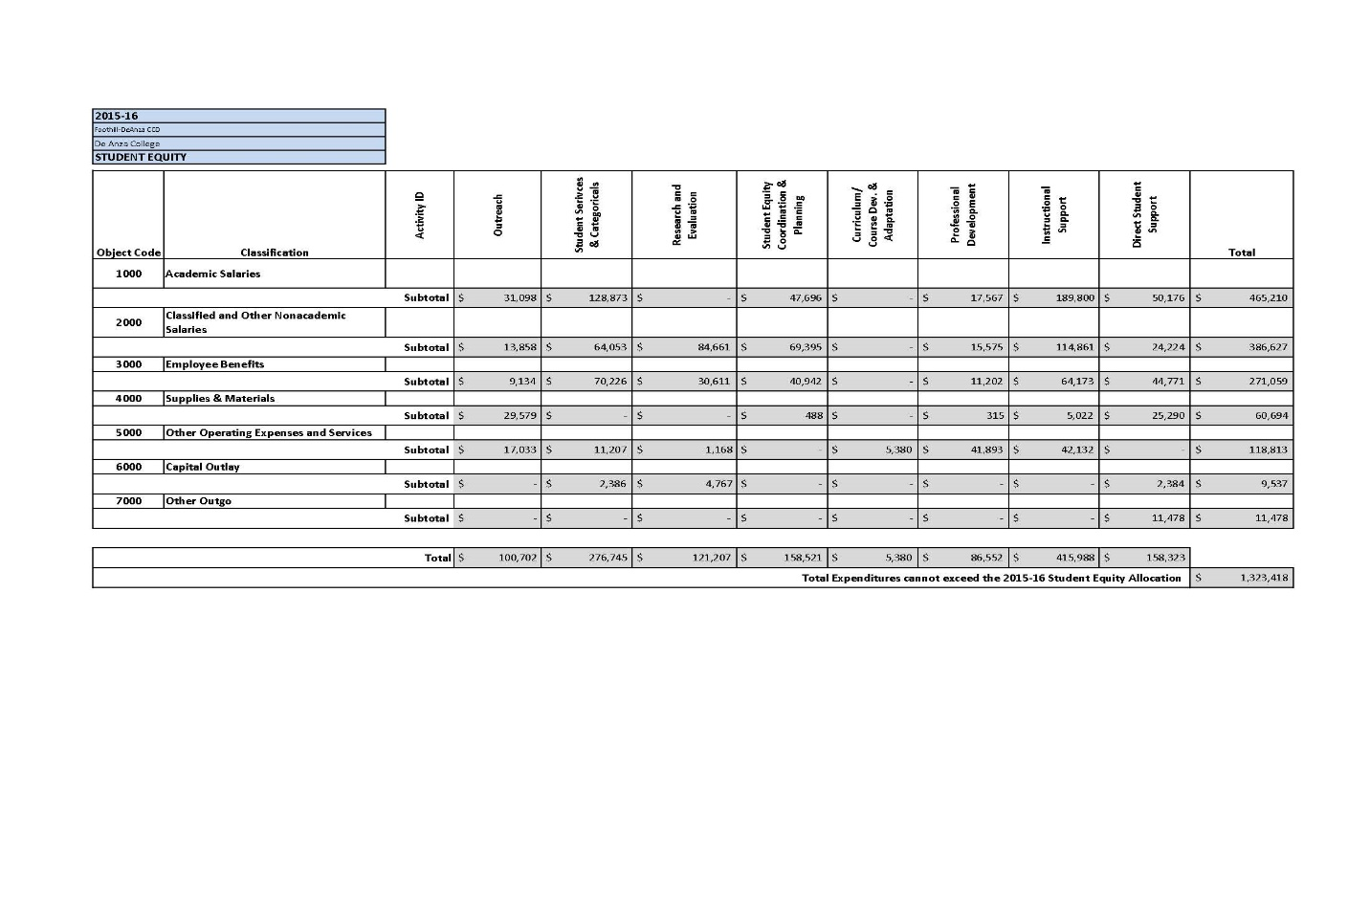
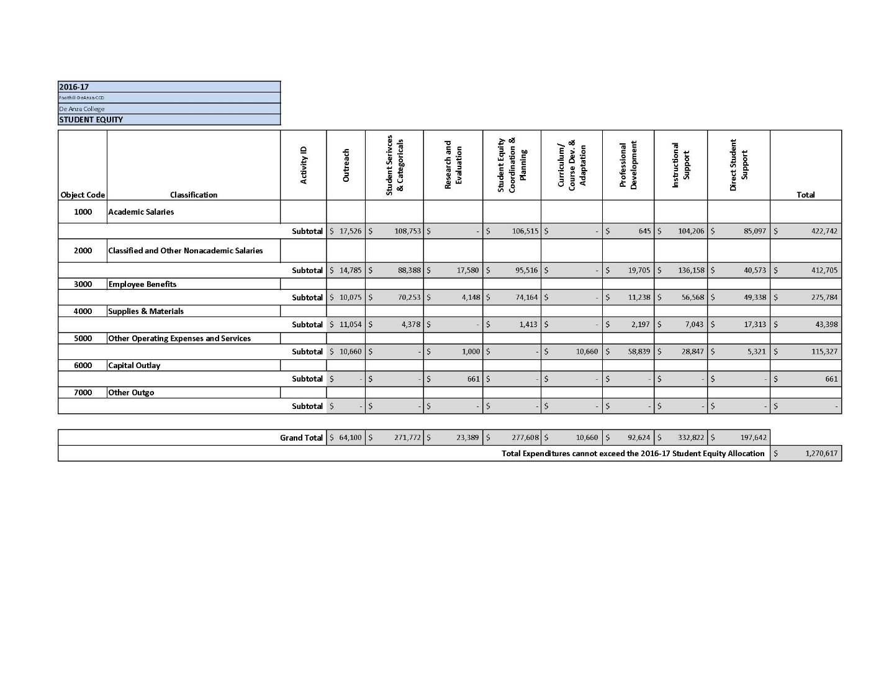
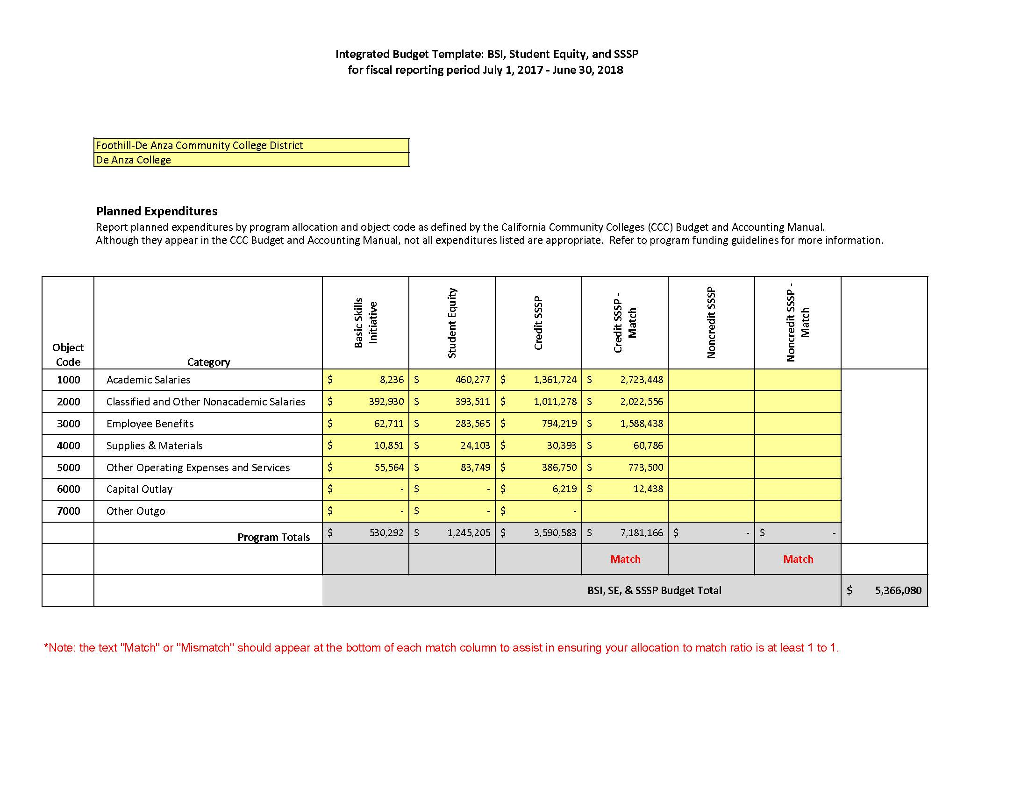

Name of Contact:
Lorrie Ranck

Alternate Point of Contact:
Mallory Newell

Approval and Signatures:

Board of Trustee Approval Date:

President:
Chief Business Officer:
Chief Student Services Officer:
President, Academic Senate:

