CHAPTER 6: THE NORMAL PROBABILITY DISTRIBUTION

Exploring the Normal Probability Distribution
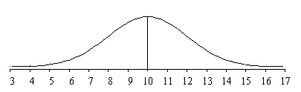
X ~ N( μ, σ)

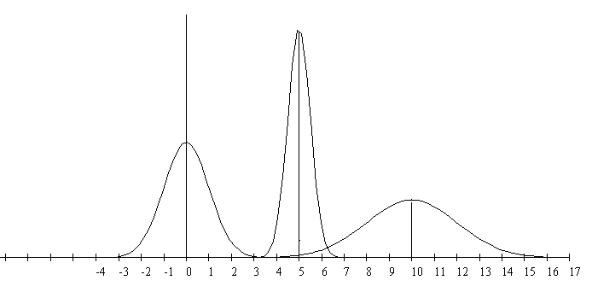

a. The normal distributions above have means µ = 5, µ = 10 and µ = 0. Identify which graph has which mean.

b. The normal distributions above have standard deviations of σ = 0.5, σ = 1 and σ = 2.
Identify graph has which standard deviation.
Normal Probability Distribution Notes, by Roberta Bloom De Anza College This work is licensed
under a Creative Commons Attribution-ShareAlike 4.0 International License.. Some material is
derived from Introductory Statistics from Open Stax (Illowsky/Dean) available for download for
free at http://cnx.org/content 11562/latest/ or https://openstax.org/details/introductory-statistics

The following are true for ANY normal probability distribution:
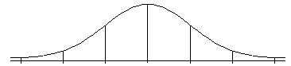

P(µ –σ < X < µ +σ) = ________

The probability for the interval within +1 standard deviations from the mean (µ + 1σ) is _________

P(µ –2σ < X < µ +2σ) = ________

The probability for the interval within + 2 standard deviations from the mean (µ + 2σ) is _________

P(µ –3σ < X < µ +3σ) = ________

The probability for the interval within + 3 standard deviations from the mean (µ + 3σ) is _________


CHAPTER 6: THE NORMAL PROBABILITY DISTRIBUTION: Calculating Probabilities
- Shade the area representing the probability.
- Label the value of the mean μ and the X values along the horizontal axis
- Label area above or inside the graph.
- Use your calculator: 2nd Distr normaldcf to find the probabilities if given X
or use 2nd Distr invnorm to find X if given the probability (invnorm requires input of area to the left)
- Write the answer as a mathematical probability statement using correct notation.

A botanist is studying the amount of time it takes for seeds to germinate (sprout) for certain type of plant. Suppose that the germination time is normally distributed with a mean (average) of 10 days with standard deviation 2 days. X = germination time for one seed

FINDING AREA IN BETWEEN  X ~ N(10, 2)  normalcdf(lower, upper, μ, σ) | P(7 < X < 9) | P(11 < X < 14)
FINDING AREA TO THE RIGHT  X ~ N(10, 2)  normalcdf(lower, 1E99, μ, σ )  normalcdf(lower, 10^99, μ, σ ) | P(X > 9) = | P(X ≥ 13) =
FINDING AREA TO THE LEFT  X ~ N(10, 2)  normalcdf( (−) 1E99, upper, μ, σ)  normalcdf( (−) 10^99, upper, μ, σ)  use (−) key for negative number | P(X ≤ 8) = | P(X < 11.5) =
FINDING PERCENTILES:  FINDING X when we know the AREA TO THE LEFT  X ~ N(10, 2)  invnorm (area to the left, μ, σ ) | 25th percentile | 80th percentile
FINDING X when we know  the AREA TO THE RIGHT  X ~ N(10, 2)  First find the area to the left  Then use the calculator  invnorm (area to the left, μ, σ ) | P(X ≥ k) = 0 .60 Find k | P(X > k) = 0 .30 Find k

CHAPTER 6: THE NORMAL PROBABILITY DISTRIBUTION: Calculating Probabilities

FINDING TWO X values when we know the AREA IN THE MIDDLE

X ~ N(10,2)

The middle 90% of values are between___________ and __________
In context of the example stated on page 2 for seed germination time of plants X~N(10,2) days,
The middle 90% of seed take between ________ and _______ days to sprout (germinate).
P(c ≤ X ≤ d) =0 .90 Find c and d:

1. First figure out the area to the left of the lower bound.  2. Then figure out area to the left of the upper bound | 3. Then use the calculator with invnorm TWICE to find the lower and upper bounds:
lower bound =
$\text{invnorm} \left(\begin{matrix}\begin{aligned}\text{area} \text{to} \text{left} \text{of} \\ \text{lower} \text{bound}\end{aligned} & , μ & , σ\end{matrix}\right)$

 | upper bound =

CHAPTER 6: THE NORMAL PROBABILITY DISTRIBUTION
Exploring Connections between Percentiles and Z-Scores

Two swimmers, Angie and Beth, from different wim teams want to compare who had the fastest time for the 50 meter freestyle race when compared relative to the other swimmers on her own team.
Suppose we also know that times for each team follow a normal distribution.
Dean, S., & Illowsky, B. OpenStax Introductor Statistics Download for free at https://openstax.org/details/introductory-statistics

Swimmer | Swimmer's Time | Team Mean Time | Team Standard Deviation
Angie | 26.2 | 27.2 | 0.8
Beth | 27.3 | 30.1 | 1.4
Which swimmer's time would be considered better (Angie or Beth) when
each is compared relative to the other swimmers on her own team?

X = time for a swimmer on Angie's team: X~_______________
Y = time for a swimmer on Beth's team: Y~________________
Calculate and compare Z-scores (we did this in chapter 2; chapter 6 re-examines this concept)

Angie | Beth

Compare percentiles for Angie and Beth by calculating probabilities using their actual GPAs

Angie: Find P(X < 26.2) for X~N(27.2, 0.8) | Beth: Find P(Y < 27.3) using Y~N(30.1, 1.4)

Compare percentiles for Angie and Beth by calculating probabilities using their z-scores

Angie: Find P(Z < −1.25) using Z ~ N(0, 1) | Beth: Find P(Z < −2) using Z ~ N(0, 1)

CONCLUSION: __________'s time of ________ minutes is considered better than __________'s time of ______ minutes when each is compared relative to other swimmers on her own team.
NOTE | - Using z-scores and percentiles lead to the equivalent results and the same conclusion..  - Using the specified normal distribution X~N(3.0, 0.7) and Y~N(80, 10) give the same probabilities and percentiles as are obtained by using the Z score with the standard normal distribution, Z ~ N(0, 1)

CHAPTER 6: THE NORMAL PROBABILITY DISTRIBUTION: PRACTICE

- Draw the graph and label all pertinent values.
- Label the value of the mean μ and the X values along the horizontal axis
- Label areas above or inside the graph.
- Use your calculator to find the requested values. Write your calculator commands.
- Write the answer as a mathematical probability statement using correct notation.

PRACTICE EXAMPLE N: In California, the wine and fruit industries invest significant resources in the study of growing grapes in order to improve crop yield and quality.
Suppose that a certain type of grape, when ripe, has diameter that is normally distributed with a mean of 1.8 cm with a standard deviation of 0.3 cm.
a. Find the probability that a randomly selected grape has diameter more than 2.2 cm

b. Find the probability that a randomly selected grape has diameter less than 1.6 cm.

c. The middle 80% of this type of grapes have diameters between _______ and _______cm.

d.Find the IQR (Interquartile Range) of diameters for this type of grape.

e. The largest 15% of grapes have diameters of at least ________________ cm.

f. Find the probability that a randomly selected grape has diameter between 1.5 and 2.0 cm
using each method as instructed below:

(i) Use X~N(1.8, 0.3) when using normalcdf on your calculator

(ii) Find z-scores for x = 1.5 and x = 2.0 and use Z~N(0,1) standard normal distribution
when using normalcdf on your calculator

