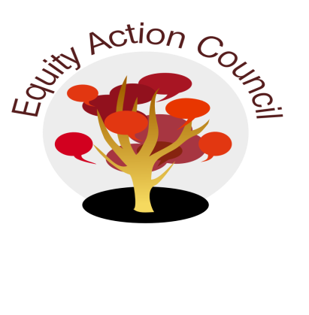
Time | Topic | Process | Facilitator(s)
1:30 pm | Introduction | Conocimiento and Check In | Edmundo Norte
1:45 pm |  | - Guided Pathways  - Committee members can access the Guided Pathways Self Assessment at: http://www.deanza.edu/gov/academicsenate/untitled.html | Karen Chow
2:10pm | Updates | - Shared Governance Student Representatives - | Angelica Esquivel Moreno  Tony Santa Ana
2:30pm |  | - Bystander Intervention Workshop by CAIR - What were the "Key Take Aways" | All
2:40pm |  | - Institutional Awareness and Response Plan Report Out | Edmundo Norte
2:50pm | Closure | - Announcements  - Appreciations | All

EAC Community Agreements
Show up, and choose to be present
Pay attention to what has heart and meaning
Tell the truth without blame or judgment
Be open to outcome, not attached to outcome
From The Four-Fold Way® by Angeles Arrien, Ph.D.

