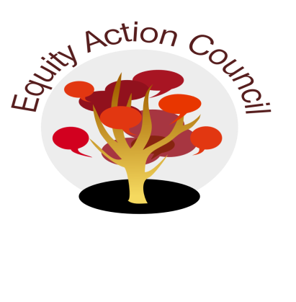
Time | Topic | Process | Facilitator(s)
1:30 pm | I | I. Introduction: Conocimiento and Check In | Melissa Aguilar
1:45 pm | I | II. Review EAC Agreements | Alicia Cortez
2:05 pm | I/D/A | IV. Subcommittee Report:  - DASB/ICC (Steffany Djuarsa, And Doan)  - Equity Champion Award ( Erick Aragon, Hyon Chu Yi-Baker & Adriana Garcia)  - Technology Advisory (Sandy Cordoza) | Erick Aragon
2:35pm | I | V. Success Plan and Student Equity Report  - Vision  - Feedback & Discussion | Mallory Newell  Alicia Cortez & Melissa Aguilar
2:45pm | I | - Announcements & Appreciations  - April 24 Ancestral Herbal Medicine 11:30am-1:30pm @ MQ3  - April 30 Lit Lunch 11:30am-12:30pm @ MLC250  - Save the Date: Equity celebration, Tues. June 18, 2019 3-5pm | Edmundo Norte

EAC Community Agreements
Show up, and choose to be present
Pay attention to what has heart and meaning
Tell the truth without blame or judgment
Be open to outcome, not attached to outcome
From The Four-Fold Way® by Angeles Arrien, Ph.D.

