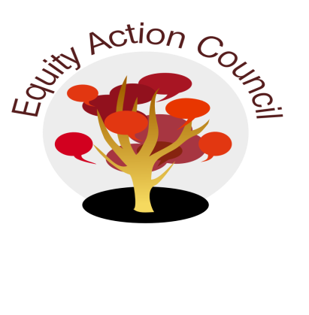
Time | Process | Topic | Facilitator(s)
1:30pm | I | I. Introduction: Welcome and Check in With Participants | Melissa Aguilar/All
1:40pm | D | II. Student Employee Living Wage | Genevieve Kolar DASB Trustee  Erick Aragon
1:50pm | D | III: Collaborative Response to the Annual Governance Reflection  https://irp.fhda.edu/cgi-bin/rws5.pl?FORM=AnnualReflection2 | Erick Aragon
2:10 pm | I | IV: Subcommittees  a. Equity Champion Awards Update  b. DASB - Student Rep  c. College Planning - Tony Santa Ana  d. Budget Update - Edmundo Norte & Melissa Aguilar? | All
2:30pm | D | V. What's working in your areas in engaging students in this new environment?  How are we keeping engaged? | Melissa Aguilar
2:40pm | I | VI. Announcements  Equity Celebration  Equity Certification Training for Classified Professionals  HEFAS Summit  End of the year Celebrations | Erick Aragon/ All
2:50pm | D | VII. Affirmations | Erick Aragon/ All

EAC Community Agreements
Show up, and choose to be present
Pay attention to what has heart and meaning
Tell the truth without blame or judgment
Be open to outcome, not attached to outcome
From The Four-Fold Way® by Angeles Arrien, Ph.D.

