DE ANZA COLLEGE
BUSINESS, COMPUTER SCIENCE & APPLIED TECHNOLOGIES DIVISION
BUSINESS 90 – PRINCIPLES OF MARKETING
Sec 65Z– Online, CRN: 31900
Winter 2018
INSTRUCTOR: Emily Garbe PhD

Welcome to Principles of Marketing! This class is completely online where we will have online readings, assignments, and mini-simulations. We will cover the fundamentals of marketing and play mini-sims which emulate decisions needed in developing an effective marketing plan. We will wrap up the course with a Marketing Plan presentation. So get ready for a fun and exciting quarter.

The assignments and deadlines are listed at the end of this syllabus, but are subject to change based on the course progress during the quarter. The instructor will make a class announcement should there be any changes to the syllabus.

Please read this document carefully as information you seek about the course process and structure should all be in this syllabus, Canvas home page, FAQs on Canvas course page, or the assignment descriptions in Canvas weekly assignment areas. Note that in this document, all URL links are embedded and designated with the names of the sites underlined. Please click on all underlined words to access the corresponding external links.

NUMBER OF UNITS: 5

ADVISORY:
English Writing 211 and Reading 211 (or Language Arts 211), or English as a Second Language 272 and 273.

STUDENT LEARNING OBJECTIVES:
By the end of the course students are expected to:
- Determine appropriate market segments and target markets and describe the major components of a fundamental model of consumer behavior.
- Analyze the effectiveness of the marketing mix (product, price, promotion, and distribution) for a particular organization.
- Identify global forces external to the organization that affect marketing strategies.
Emphasis in the course is on key terminologies, critical analysis, strategic concepts and managerial decision-making in marketing as it is conducted today in world-class business firms.

INSTRUCTOR CONTACT INFORMATION:
- Office hours: M-R 10:30-11:20 am (no appointments needed)
- Office location: Business lab (ATC 203D – enter from outside door only, not through the CIS Lab)
- Contact the instructor via Canvas Messaging (please do not use email or the comment fields within an assignment). The instructor will try to answer the messages within 48 business hours or likely much sooner.

CLASS MATERIALS:
- Marketing – Real People, Real Choices, 9/e by Solomon, Marshall & Stuart
- Pearson MyLab
There is a new process for purchasing Pearson etext and MyLab materials called "DDR" (Direct Digital Access). At the start of the quarter, students automatically have access to etext/MyLab via Canvas by entering the access code listed below. Students then have 2 weeks to pay for the materials otherwise their accounts will be cancelled by the Bookstore.
Students can pay for the materials by either (1) going to the De Anza Bookstore in person, or (2) buying from the De Anza bookstore website online. Note that the $69 is a special negotiated price only from the De Anza bookstore. The printed textbook priced at $60 is optional as an add-on to the ebook/MyLab. Access codes purchased from Amazon and other websites would not work since this material is specifically for this course only.
To purchase, please follow the steps below:
- At the start of the quarter, log into your De Anza College Canvas Account and select “BUS 90 Sec 65Z”. Canvas homepage is available at the start of the quarter.
- Select “MyLab & Mastering” from the left-hand menu, then select “Open MyLab” option in the center of your screen.
- Enter your Pearson MyLab username and password. If you have used a Pearson product previously, such as MyMathLab, MyEconLab, etc, then use the same user name and password. If you are new to Pearson MyLab, then select “Create” and follow the instructions.
- Select “Access Code” after login, and enter code: MYMARK-PRINK-CURCH-ACERB-SARTO-JADES. You can now access MyLab and etext. This code will be revoked by De Anza bookstore & Pearson if you failed to pay for the material by the drop date.
- Next, you need to pay for the materials. If you would like to pay online, click on this bookstore link. If you would like to purchase in person, or if you are using financial aids, please go to the De Anza bookstore, not the instructor. You will need to fill out an “opt-in” form” when paying in person at the bookstore.
- Accounts not paid by the drop date 1/21/18 will be automatically deleted by Pearson. Do not contact the instructor regarding any payment or financial aids since the instructor has no role in account creations, payments, or account deletions. All students whose access are revoked by the De Anza Bookstore will be dropped from the course by the instructor upon notification by the Bookstore (which means no refund for the course since this would occur after the De Anza deadline for refund.)

COURSE ACTIVITIES:
- Chapter reading
- Chapter video case study and video quizzes (10 min, 1 attempt)
- Chapter mini-sims (unlimited time, 2 attempts, likely 5-10 min per sim)
- Chapter quizzes (20 min per quiz, 2 attempts)
- Discussion forums (unlimited time)
- Marketing plan (submit early for extra credits)

The instructor has set up direct seamless links to each assignment from Canvas course page. Please access the assignments by clicking on each of the assignment link in Canvas weekly assignment area, not from Pearson website.
You will need to access the resources and assignments listed below:
- All registered students must use De Anza’s courseware Canvas to access the course homepage where access to all the course materials reside.
- Read the lecture slides for the assigned chapters. You may want to print out the lecture slides, and use them as the study guide for the chapters.
- Read the etext by clicking on the MyLab tab at Canvas course homepage.
- Watch the videos for the assigned chapters and take the video quizzes. Make sure you enable pop-up in your browser.
- Complete the mini-sim(s) for the assigned chapters. Make sure you enable Java and cookies in your browser. Access mini-sims from Canvas weekly assignment area.
- Take the open-book online chapter quizzes only after you have studied the chapters.
- Complete the class forums and writing assignments.
- Upload term project (Marketing Plan PowerPoint and Youtube presentation link).

GETTING HELP:
Please click on the help button on the lower left of your Canvas screen for tech support, or upper right hand corner “?” for Pearson MyLab help desk. Please do not ask the instructor for tech support since the Pearson and Canvas are much better positioned to help you.

For questions about course contents, please come to the instructor’s office hours in the Business Lab (ATC203D). Or you can contact the instructor via Canvas Inbox (not via email), so we can keep track of all communications.

SYSTEMS AND NETWORK REQUIREMENTS:

Access to a computer and the Internet:
A computer is required for submitting your assignments. You may use your own computer for Internet access; or, if you prefer, you can use the computers in either the De Anza library or the Library West Computer Lab. Hand-written papers will not be accepted. Not having time to go to the library to use the computers is not a valid excuse for incomplete assignments.

Canvas:
Canvas supports the current and first previous major releases of the following browsers:
- Internet Explorer 11 and Edge (Windows only—please make sure your operating system is also current as noted in the computer specifications lesson; you may need to download the Windows 10 Anniversary Update to submit Canvas assignments)
- Safari 8 and 9 (Macintosh only)
- Chrome 52 and 53
- Firefox 47 and 48 (Extended Releases are not supported)
- Flash 22 and 23 (used for recording or viewing audio/video and uploading files)

We highly recommend updating to the most current version of your preferred browser. Your browser will notify you if there is a new version available.
Run the readiness test by clicking on this link so that you can test your browser and see what plug-ins you might need.

Pearson MyLab/etext:
Pop-up, Java, and cookies need to be enabled to view the videos and run the simulations. For Google Chrome, go to “setting”, “advance setting”, “privacy”, “content setting”, “pop ups”, “allow”. For more details or for other browsers, please follow this link to make sure your computer support Pearson MyLab. Follow the instructions listed in this Pearson link very carefully and do exactly what was recommended for Java, popups and cookies. For cookies, include “pearson.com”, “pearsoned.com” and “mathxl.com” in “Manage exceptions” of cookies settings. The Pearson link above has detail instructions and screen shots to guide you. For instructor’s own experience, Safari on Apple and Firefox on Windows seem to run better. However, Pearson recommends IE or Chrome. Please try different browsers to see which runs best on your own system. If that does not work, try another computer.

Not able to run videos or not able to see the etext, videos, quizzes, or sims are not valid reasons for missing assignments. Again, please contact Pearson help desk if you have any technical issues, not the instructor.

Course Home Page:
Log into Canvas at with your De Anza ID. You can access your Canvas course home page at the start of the quarter.

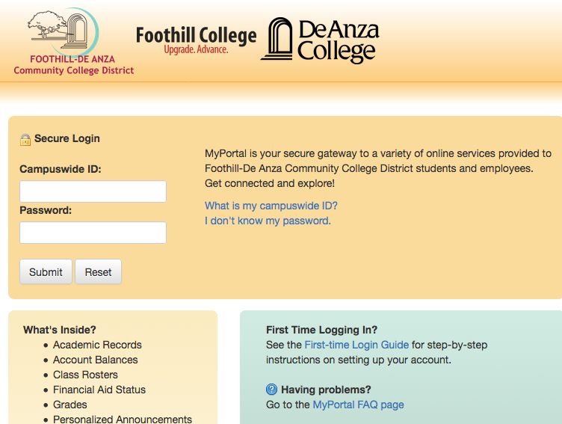

Once you log in to Canvas, you will see a list of courses you have registered that has a Canvas component. Click on BUS90 to go to our course home page.

Click “MyLab and Mastering” for etext.

Click on the appropriate week button for each week’s assignment module.
Click on “Grades” to keep track of your own progress.

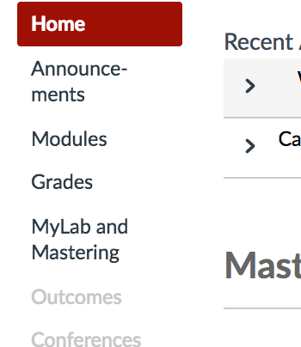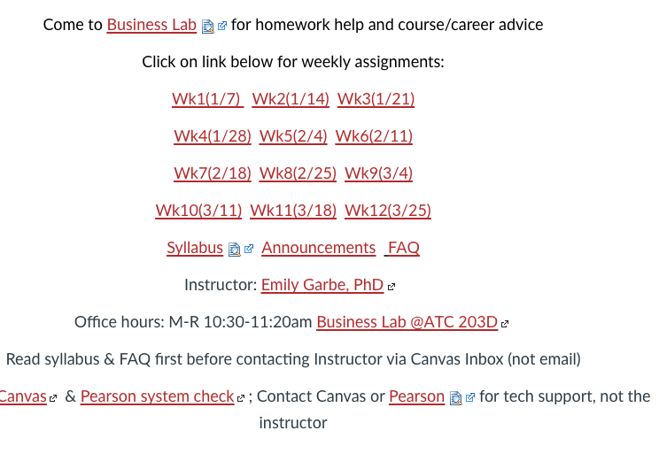
Within each week’s module, there are two sections: Resources and Assignments. Follow the list under Resources for chapter readings, lecture slides, and any additional videos or weblinks. To access the textbook, click on “MyLab” then “etext”. You can also download the Pearson etext app onto a mobile device and read your chapters on the mobile device. However, you need to complete and submit the assignments on a computer, not a mobile device.

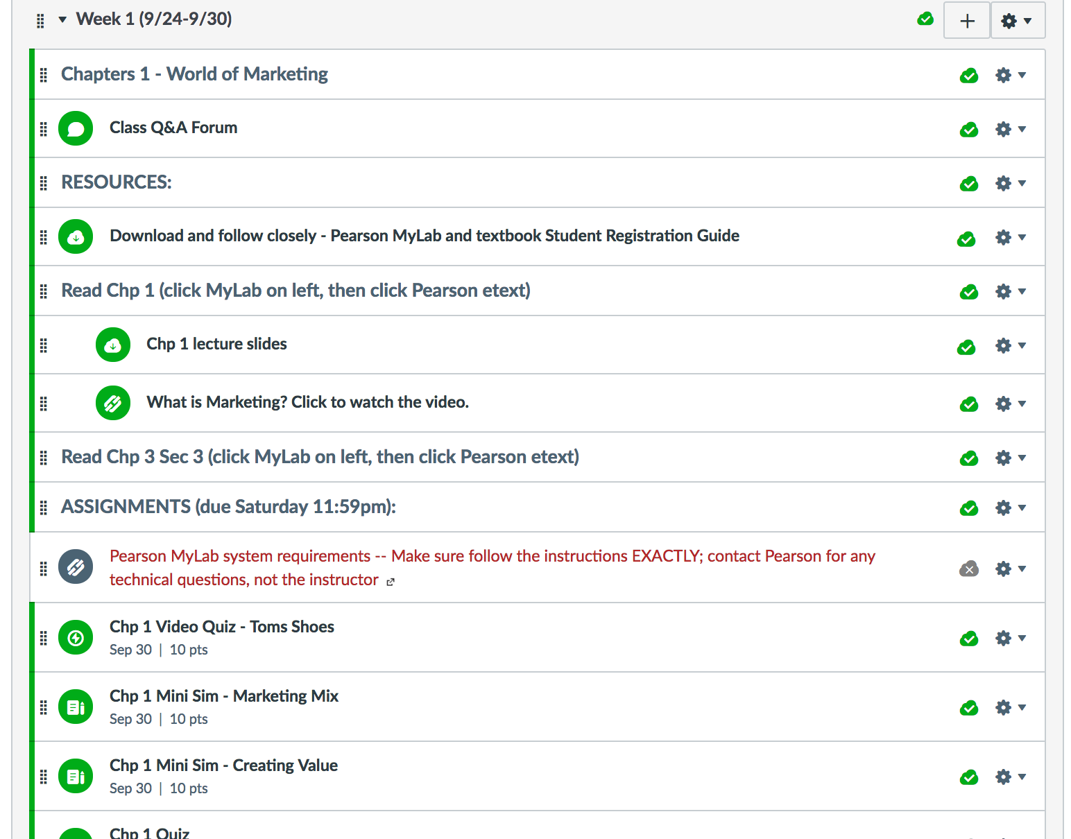

All assignments are due on either Wednesday or Saturday, except for Week 12 due on Tuesday. Complete each assignment by clicking on each mini-sims, video quizzes and chapter quiz links which will lead you seamlessly to Pearson MyLab. Discussion forums and marketing plan are local to Canvas where you need to complete the assignments based on the grading rubrics and project descriptions.

CLASS PARTICIPATION:
Students must complete all assignments during Week 1, not just a selected few. Partial completion of Week 1 assignment is considered non-participation and will be dropped by the instructor. The instructor will not assign grades to any assignments for a student until the student has completed and uploaded the Student Course Agreement as listed in Week1 of Canvas assignment area.

Assignments are available two weeks ahead of the due dates as listed at the end of this syllabus; please plan your time accordingly and work ahead – do not wait till the due date. Since the assignments and readings are available 7x24 online (accessible anytime anywhere) two weeks in advance, the only valid reasons for late assignments or requesting an Incomplete for the course are major medical emergency/hospitalization (yourself or child/significant other), National Guard, or jury duty/court appearance, all with official proofs. Travel, work schedule, non-emergency/non-hospitalized illnesses, family matters, vacation, forgetting, work conflicts, busy with another class, and personal issues are not valid reasons for not submitting the assignments.

Important note: If you have a busy school week ahead, or have frequent or high likelihood of family issues or work conflicts, please complete the assignments early rather than waiting until the due dates. You have 14 days to find time for your reading and assignments. However, if two weeks in advance is not sufficient, please let the instructor know so that accommodations can be made to fit your needs.

There are 3 free passes for the mini-sims, video quizzes and chapter quizzes to cover any missed due dates you may incur.

Timely completion of assignments is essential as learning in this class is built on top of the previous chapters. As such, for those students who add the class with an add code, the record of assignment submissions and participation maintained by the instructor begins with the day the students are given the add code by the instructor.

No late submissions or re-grading of assignments will be permitted since answers are made available after the due dates.

Based on the De Anza Student Handbook, to request an incomplete on the transcript, a student must have completed at least 75% of the course assignments. If a student wants or needs to drop the class, the student is solely responsible for dropping the course. See De Anza’s policies and deadlines for attendance and drop/add/withdraw calendar.

GRADING POLICY:
College professors do not give grades; students earn them. Below is a breakdown of the earnable points from assignments.
Note that Canvas will drop lowest grades assignments per the table below at the end of the quarter. So if you did not do well in one or two assignments, had systems issues, or forgot/missed them, do not panic and never ask the instructor to extend or restart just for you as it would not be fair to others in the class.

Points earned from each MyLab assignment will be transferred to Canvas by the instructor after the due dates.

Activities | Canvas Points | % of total
Video quizzes | 80 (10 points per case, 11 videos, 3 lowest grades dropped) | 8%
Mini sims | 140 (10 points per sim, 17 sims, 3 lowest grades dropped) | 14%
Chapter quizzes | 500 (50 points per quiz, 13 quizzes, 3 lowest grades dropped) | 50%
Student course agreement | 5 | 0.5%
Discussion forums | 190 (Gamification 60 pts, PLC 60 pts, Global forces 60 pts, self intro 10 pts) | 19%
Marketing plan | 85 | 8.5%

Letter grades will be assigned to students based on their total points, which is calculated as a sum of the assignments, as described above, divided by 1,000 points.

The following table for letter grades is finite and not negotiable. To be fair to your fellow classmates, do not ask the instructor to change the cutoff for the letter grades for you.

Total % | Letter grade
97% or above | A+
93%-96.9% | A
90%-92.9% | A-
87%-89.9% | B+
83%-86.9% | B
80%-82.9% | B-
77%-79.9% | C+
70%-76.9% | C
67%-69.9% | D+
63%-66.9% | D
60%-62.9% | D-
59.9% or below | F

ACCOMMODATIONS:
Students with learning disabilities are encouraged to make arrangements with the De Anza Disabled Student Services DSS if you need extra time on the quizzes. Students who are unsure whether they have a learning disability are encouraged to contact the Disability Programs and Support Services as soon as possible to determine eligibility. Please submit your DSS form to the instructor if you need accommodations. The instructor cannot make accommodations without written instructions from DSS.

Pearson MyLab and Canvas provides accessibility accommodations for all etext, sims, and videos. Please follow the instructions as indicated by Pearson and Canvas.

ACADEMIC INTEGRITY:
Students are expected to abide by the Student Conduct Rules as described in the Student Handbook. For all assignments, never copy any materials from another student, or from the Internet. Any assignments with un-cited materials copied from the Internet, another De Anza student (current or prior students) or students from another college as determined by the instructor or turnitin.com will be viewed as plagiarism and will be immediately referred to De Anza’s Dean of EOPS & Student Development for actions.

Students must complete their own assignments. Students who lie to the instructor or are disrespectful to fellow students or the instructor will be immediately referred to the Dean for disciplinary actions.

Business 90 – Winter 2018
Weeks | Reading assignments | Quizzes & Assignments (due 11:59pm)*
Week 1  (1/8-1/14) | Chapter 1 – World of Marketing | Due Wednesday 1/10:  Student course agreement  Discussion Forum: Self-intro  Due Sunday 1/14:  Chp 1 Video – Toms Shoes  Chp 1 Mini Sim – Creating Value  Chp 1 quiz
Week 2  (1/15-1/21) | Chapter 4 – Market Research | Due Wednesday 1/17:  Chp 4 Mini Sim – Market research  Chp 4 quiz
 | Chapter 5 – Market Analytic | Due Sunday 1/21:  Chp 5 Mini Sim – Big data  Chp 5 quiz
Week 3  (1/22-1/28) | Chapter 6 – Understand Markets | Due Wednesday 1/24:  Discussion Forum: Gamification  Due Sunday 1/28:  Chp 6 Video – Eaton  Chp 6 Mini Sim – Buyer decision process  Chp 6 quiz
Week 4  (1/29-2/4) | Chapter 7 – Segmentation | Due Wednesday 1/31:  Chp 7 Video – NutriSystem  Chp 7 Mini Sim – Segmentation  Chp 7 quiz
 | Chapter 8 – New Product Development | Due Sunday 2/4:  4P review: Chp 1 Mini Sim – Marketing Mix  Chp 8 Video – Honest Tea  Chp 8 quiz
Week 5  (2/5-2/11) | Chapter 9 – Product Strategy and Branding | Due Wednesday 2/7:  Chp 9 Video – Fiber One  Chp 9 Mini Sim – Product Life Cycle  Chp 9 quiz  Due Sunday 2/11:  Discussion Forum: PLC
Week 6  (2/12-2/18) | Chapter 10 – Pricing | Due Sunday 2/18:  Chp 10 Video – General Electric  Chp 10 Mini Sim – Pricing  Chp 10 Mini Sim – Pricing Strategies  Chp 10 quiz
Week 7  (2/19-2/25) | Chapter 13 – Advertising and Sales Promotion | Due Sunday 2/25:  Chp 13 Video – Zappos  Chp 13 Mini Sim – Advertising  Chp 13 Mini Sim – IMC  Chp 13 quiz
Week 8  (2/26-3/4) | Chapter 14 – Social Media Marketing, Selling and PR | Due Sunday 3/4:  Chp 14 Video – Principal Financial Group  Chp 14 Mini Sim – Online Marketing  Chp 14 Mini Sim – Personal Selling  Chp 14 quiz
Week 9  (3/5-3/11) | Chapter 11 – Distribution Strategy | Due Sunday 3/11:  Chp 11 Video – Dunkin Donuts  Chp 11 Mini Sim – Supply Chain  Chp 11 quiz  Submit Term Project early for extra credits
Week 10  (3/12-3/18) | Chapter 3.3 – Marketing Plan | Due Sunday 3/18:  Term project: Marketing Plan PowerPoint and video
Week 11  (3/19-3/25) | Chapter 2– Global Marketing | Due Wednesday 3/21:  Chp 2 Video – Monster.com  Chp 2 Mini Sim – Global Marketing  Chp 2 quiz  Due Sunday 3/25:  Discussion: Global forces
Week 12  Assignments due Tuesday 3/27 | Chapter 12 – Bricks and Clicks | Due Tuesday 3/27:  Chp 12 Video – Umpqua Bank  Chp 12 Mini Sim – Service Marketing  Chp 12 Mini Sim – Retailing  Chp 12 quiz
*See course page in Canvas for details about the assignments.
De Anza College DSPS Syllabus Statement

De Anza College views disability as an important aspect of diversity, and is committed to providing equitable access to learning opportunities for all students. Disability Support Services (DSS) is the campus office that collaborates with students who have disabilities to provide and/or arrange reasonable accommodations
- If you have, or think you have, a disability in any area such as, mental health, attention, learning, chronic health, sensory, or physical, please contact DSS to arrange a confidential discussion regarding equitable access and reasonable accommodations.
- If you are registered with DSS and have accommodations set by a DSS counselor, please be sure that your instructor has received your accommodation letter from Clockwork early in the quarter to review how the accommodations will be applied in the course.
Students who need accommodated test proctoring must make appointment at the Testing Center.
- Exams must be booked at least five (5) business days in advance of the instructor approved exam date/time.
- Finals exams must be scheduled seven (7) business days/weekdays in advance of the instructor approved exam date/time.
- Failure to meet appointment-booking deadlines will result in the forfeit of testing accommodations and you will be required to take your exam in class.
- Contact the DSS if you cannot find or utilize your MyPortal Clockwork Portal.
- DSS strives to provide accommodations in a reasonable and timely manner, some accommodations may take additional time to arrange. We encourage you to work with DSS and your faculty as early in the quarter as possible so that we may ensure that your learning experience is accessible and successful.
DSS Location: RSS Building, Suite 141
Phone: 408-864-8753
Email: DSS@deanza.edu

